Adiyaprava Sen

CSE 2nd Year

Roll-56

Output Screenshot

Q1-3.

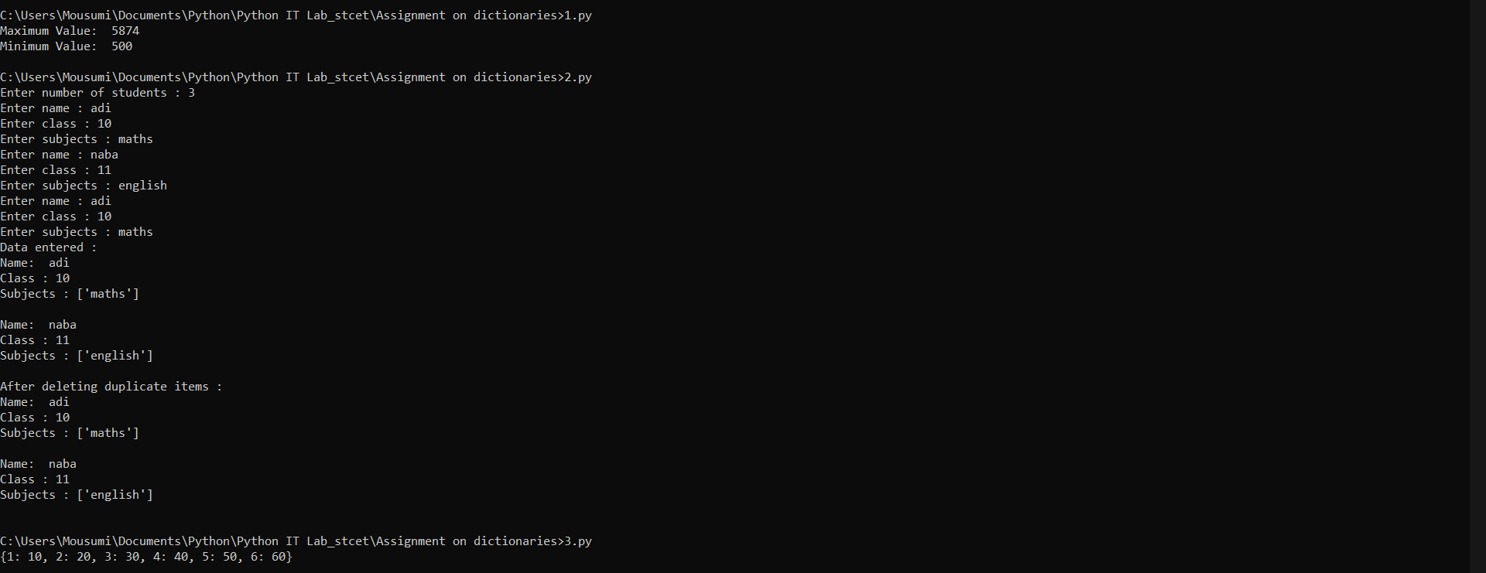

Q4-7

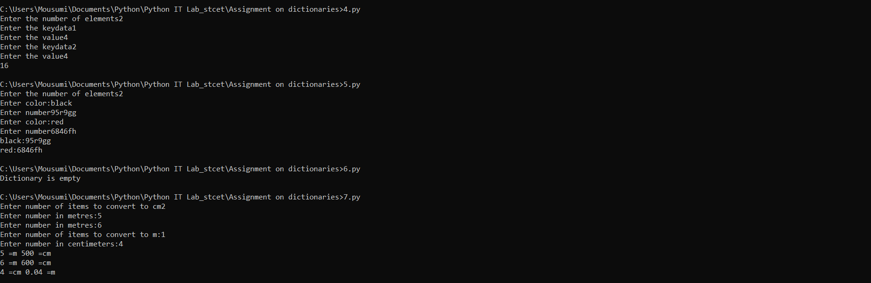

Q8.

